**The Influence of Policies on the Spread of Covid-19 in Different Networks**

Jingjie Zhu

Yangyin Wang

Shuo Tian

INFSCI 2125

# Abstract

Although the new coronavirus has lasted for nearly a year, people have not been able to control the virus effectively. The Chinese government has managed to contain the outbreak for a short time through strict home quarantine, but this approach is not easily followed by other countries. Therefore, we established different neural networks to observe the impact of different levels of home quarantine policies on the spread of the epidemic. Our results show that stringent policies can effectively contain the spread of the virus, but it is difficult to eliminate the virus completely, it still has the possibility of a second outbreak. In addition, when viruses spread in the Community Structure network, the first wave is significantly lower than the peak of the first wave in the Barabási–Albert model network.

# Introduction

As of 3 December 2020, covid-19 has spread to more than 218 Countries and Territories and caused more than 1.5 million deaths. The government made a series of policies to control the spread of the epidemic, such as asking people to keep the social distance and wear masks, close restaurants and so on. Partly because of these policies, medical resources have not been overstretched. Hence, we simulated the impact of medical resources on mortality. Also, when the epidemic improves, the policy will be less forceful, which could lead to a second outbreak. Therefore, in our network, we set the policy intensity as a negative correlation function of the epidemic degree. Observe a model of epidemic transmission under these conditions. At the same time, under the home quarantine policy, people's relationship network becomes more similar to the community structure. We also hope to find out how effective the home quarantine policy is.

# The Design of Proposal Model

In this study, we established three different networks to simulate the spread of the virus. They are a Erdős–Rényi model (Figure. 1a), a normal Barabási–Albert model (Figure. 1b), and a Barabási–Albert model (Figure. 1c) with community structure.

|  |  |  |
| --- | --- | --- |
| a. | b. | c. |

|  |
| --- |
| d.  The compartmental model describes what state is the person infected with covid-19 in. We consider Susceptible(all the people that has at least one connections to others), infected(people are infected covid-19),Asymptomatic, Symptomatic, temporary immunity (People who recover from COVID-19 and they don't get reinfected for a while), Home(people are asked to quarantine at home), hospital(patient whose condition deteriorated and they had to be treated in hospital) and Dead. |

Figure 1: Model

The whole simulation program is divided into three parts: First one is prune which has three functions. The policy will reduce the weight of all edges, which simulates the government asking people to wear masks. The home prune will only reduce the nodes who are in this state. Escape the most intimate families, all the other weights of edges will decrease to zero. As for the hospital, all the weights of edges of that node will decline to zero which means the virus is not able to spread in the hospital. The second step is determination and recovery, they will determine whether nodes will be infected this turn and reset the attributes for nodes which will recover in this turn. The last step is the determination of node state. We use a compartmental model as (Figure. 1d) shows. When a node is infected, the probability of that node is asymptomatic is (P1), after (D1) days, it still has a (P2) probability of converting to symptomatic node. As for the nodes in state(symptomatic) and (home), it will be asked to transfer to state (home) or (hospital) after(D2) days with a probability of 1 and (P3). In other words, D1 is the time from the onset of symptoms until the patient is diagnosed and is therefore forced to quarantine at home, D3 is the time it takes to wait to enter the hospital, and (P3) is the probability that the patient's condition will deteriorate into severe illness. (P4) means the cure rate in the hospital.

In addition, when a node goes from state (symptomatic) to state (home) and from state (home) state to (hospital), we will prune its weight by different strategies.

# Medical Breakdown

As mentioned before, we build our model first as a tool to investigate assumptions on the spread of COVID-19. Firstly, we want to figure out why it is critical to order people to stay home or quarantine. A possible reason is medical breakdown, which means some infected people run out of all available medical resources and others have to wait for the medical services without any professional help. To simulate this process, we change the time duration between the infected people testing positive and getting hospitalized.

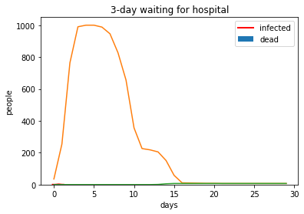

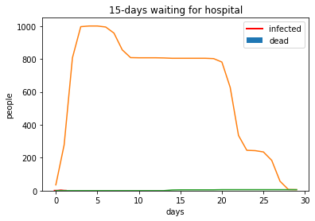

Figure 2

As figure 2 shows, the spread of virus decreases quickly after 5 days when the infected people with severe symptoms go to hospital after 3 days waiting time.(also means the higher infection weights with neighbours in the network graph decreases quickly). In contrast, if the waiting period is extended to 15 days, the duration of the spread lasts 30 days.

Even though not all infected people need to go to hospital, yet for those patients who need medical help, they have to wait longer due to medical breakdown. Medical breakdown may lead to the longer waiting time for severe patients with COVID-19 to be hospitalized. It also increases the chances to spread the virus even if patients are isolated or quarantined at home.

Another critical influence comes from the infected people who do not obey the quarantine and isolation orders. They are not only exposed to the danger of suddenly worsening situations but also making others stay in the risky environment to be infected.

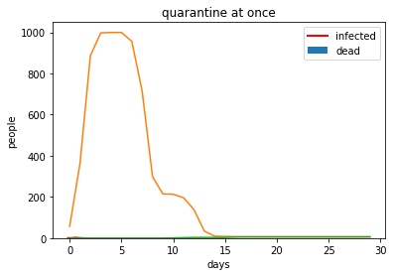

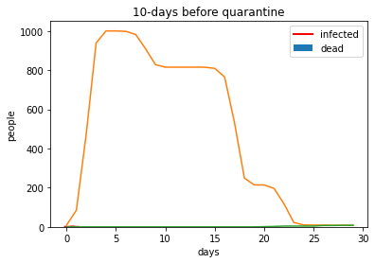

Figure 3

The figure 3 shows the difference of the quarantine effectiveness. If all infected people stay quarantine at once when they have symptoms of COVID-19. In a small sample set, the pandemic disappears after 15 days. As a comparison, the pandemic breaks out and spreads longer and wider if there are more activities of infected people. The pandemic lasts longer when the infected people keep normal activities until they start to quarantine. Consequently, it’s key to make sure that each infected person stays quarantine or isolated once they test positive. The activity of infected people can cause the pandemic breaking out.

# Policy Effectiveness

Such situations show the importance of public health policy. A fast and effective public health policy has been proven to be successful to stop the spread of the virus in Asia. However, the collected data of mobile phone usage in North America[1] suggests the effectiveness of public policy against virus like stay at home order and travel restrictions decreases day by day.

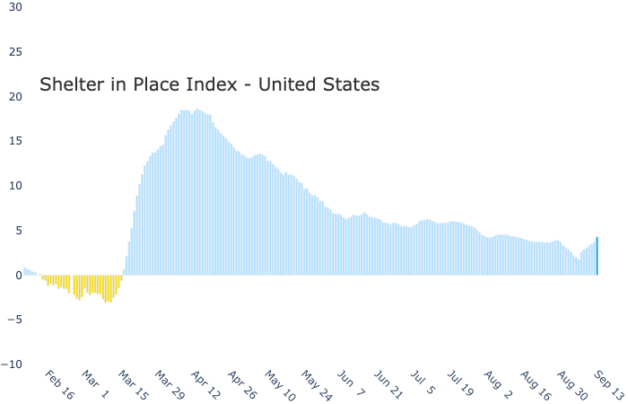

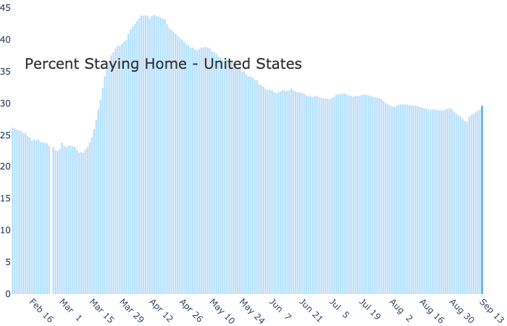

Figure 4[2]

In order to simulate the influence of policies, we need to have a basic analysis of policy effectiveness. Setyawan and Lestari’s[2] research investigates the effectiveness of stay-at-home policy during the epidemic. They used mobile data usage as an index of the effectiveness of public policies. And we found that the highest effectiveness happened in April to May, and this is when the first epidemic peak outbreak. After that, the policy effectiveness kept decreasing. According to this analysis, we design a dynamic policy system. If the proportion of infected people increases, then the policy effectiveness will increase, otherwise, it will decrease. At the same time, it will decrease by the time. Because people could be tired of staying home policy and disobey it.

# Results

|  |  |
| --- | --- |
| a. | b. |
| c. | d. |

Figure. 3: Results

The graph **a** and **b** shows simulation results on the BA model. **a**, The simulation without public policy. Weights between neighbors stayed the same. The first peak came up on day 10, and when the first epidemic broke out, all 1000 nodes got infected. Because of the temporary immunity, the second peak came in a short period. There are multiple peaks in the graph. Although at each peak, the amount of infection decreases from the previous peak, the epidemic is not under control. **b**, The simulation of the situation where the government announced public policy at the beginning of the epidemic. In this situation, the first outbreak is not delayed by policy,which is still on day 10, however, only 70% of people are infected at the first peak. And there is no second peak. The epidemic is under control. c, The simulation of the model with community structure if policy announced. Only 40% of people are infected at first outbreak, it’s even better than the BA model. The result is similar to the result of the BA model; the epidemic is under control. **d**, The simulation of the model of ER model with policy announced. The result is quite different from the other two models. At the first outbreak, all nodes are infected. It is due to different topology among these three network models. But there is no further peak in the graph either.

# Discussion and Future Work

The results we get from BA network is close to real-world data. Which means we can do tests with this basic simulation model. Results of these three simulations show the difference of announcing public policy or not. Models with policy may have different outbreak patterns, but they are all under control after the first peak. According to the simulation, we confirm strict policy will control the epidemic. And staying quarantined if getting infected is another key to stop the spread.

With this basic simulation model, there are many future works to do. Like what will happen if we implement virus testing in our simulation. infected people who have symptoms or not will be noticed, and they will stay at home immediately. It will cut the spread quickly. But not everyone has the chance to take a test. Another modification is that older people have a greater chance to be infected and less chance to recover. And older people are more likely to follow the public policy, however, teenagers are more likely to disobey the policy. With this assumption, We can design different policy strategies. Last but not least, we could build a network with Real-World data in a specific region to get more accuracy results.

Here is our source code:

<https://colab.research.google.com/drive/1xjDIcb9KS0LhfurgCGl2a94BUOFJ5lVZ?usp=sharing>

# References

[1] Aleta, A., Martin-Corral, D., y Piontti, A. P., Ajelli, M., Litvinova, M., Chinazzi, M., ... & Pentland, A. (2020). Modeling the impact of social distancing, testing, contact tracing and household quarantine on second-wave scenarios of the COVID-19 epidemic. medRxiv

[2]Centers for Disease Control and Prevention. *Pandemic Planning Scenarios(2020);*

<https://www.cdc.gov/coronavirus/2019-ncov/hcp/planning-scenarios.html>

[3] Setyawan, F. E. B., & Lestari, R. (2020). Challenges of Stay-At-Home Policy Implementation During the Coronavirus (Covid-19) Pandemic in Indonesia. Jurnal Administrasi Kesehatan Indonesia, 8(2), 15-20.

[4] Worldometer. *Covid-19 coronavirus pandemic(2020);* <https://www.worldometers.info/coronavirus/country/holy-see/>

[5] World Health Organization. *Novel Coronavirus—China* (2020); <https://www.who.int/csr/don/12-january-2020-novel-coronavirus-china/en/>

1. https://www.safegraph.com/data-examples/covid19-shelter-in-place?s=US&d=09-13-2020&t=counties&m=index
2. https://www.safegraph.com/data-examples/covid19-shelter-in-place?s=US&d=09-13-2020&t=counties&m=percent